***Infrared Receiver (VS1838B)***

Size: 7.4 x 6.2 x 5.3 mm (length x wide x high)

Range of Working Voltage: 2.7-5.5V

Max Range: 20M

Length of Feet: 23mm

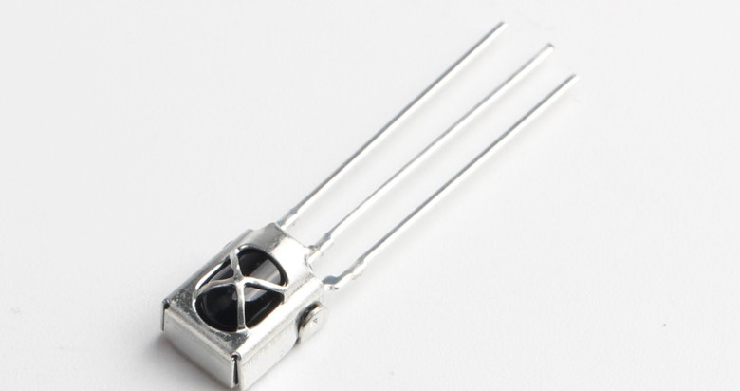

Pins From above to bottom: Vcc, GND, DataOut

Source: <https://www.elecparts101.com/vs1838b-ir-remote-control-infrared-receiver-datasheet-and-pinout/>